# **Marketing Research**

# **Assignment #8a**

**Part A: Questions 1 to 8d (30 points)**

### **For Assignment #8a (and all remaining assignments), we will use the data file for Powerade that I posted on blackboard. Remember that each group will use a slightly different version of the data – see the grade center in blackboard for your group number and corresponding data set to use.**

**All of your pivot tables should include the sample size!**

1. **(Raw Data)** Down load the actual/raw data file for Powerade (i.e. the file that I provide). The data file is on blackboard. **Copy and paste a portion of the raw data file into your homework.**

**Note for the raw data for Powerade, the file has already been partially put into a partially correct format, so it may look a little bit different than you expect.**

**Also, each group will use a slightly different data set. Your group number is posted on blackboard. You only need to download the data set corresponding to your group number.**

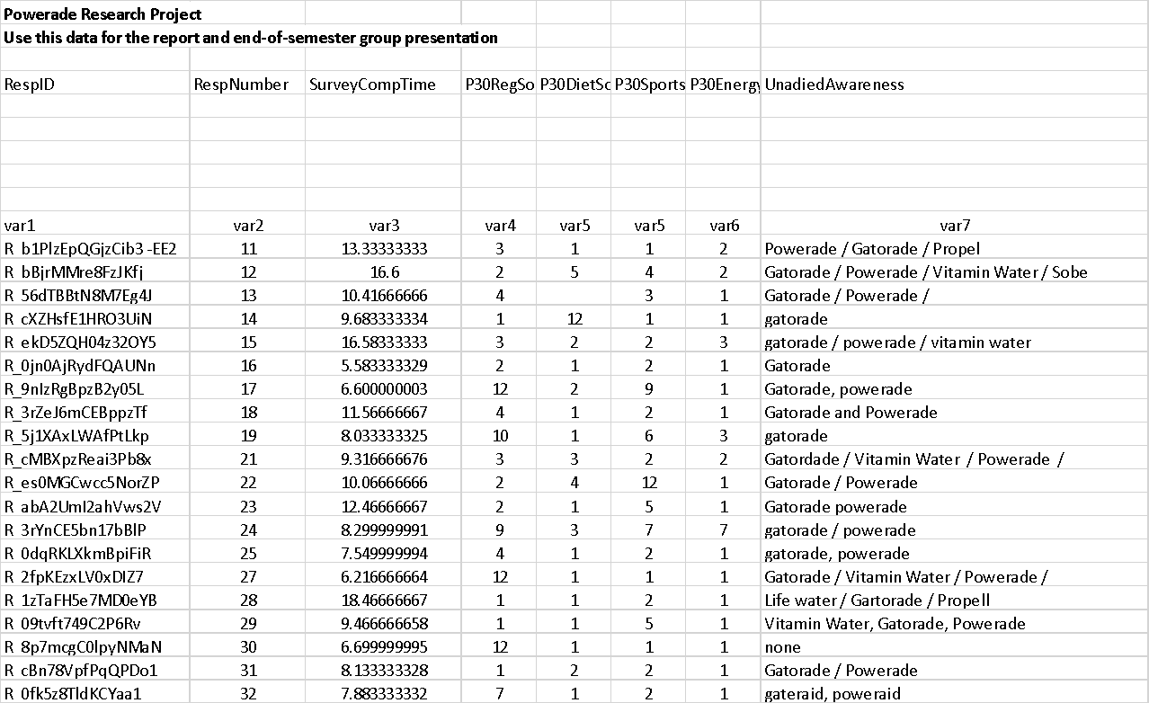

2. **(Formatted Data)** Please complete the following steps related to the editing and coding of your data file. All of this can be completed in XL (no SPSS needed for this assignment).

Modify the file so that it is in the proper format for analysis (i.e. variable names in the first row, data in the second row, etc.). **Cut and copy a portion of your formatted data file into your assignment (in WORD). Be sure to copy and paste a sufficient amount of your XL spreadsheet so that I can see that you have fully answered the question**

Note: this will only be slightly different than the copy and paste for Q1. Still, you need to put the file into the correct format to complete the rest of the assignment.

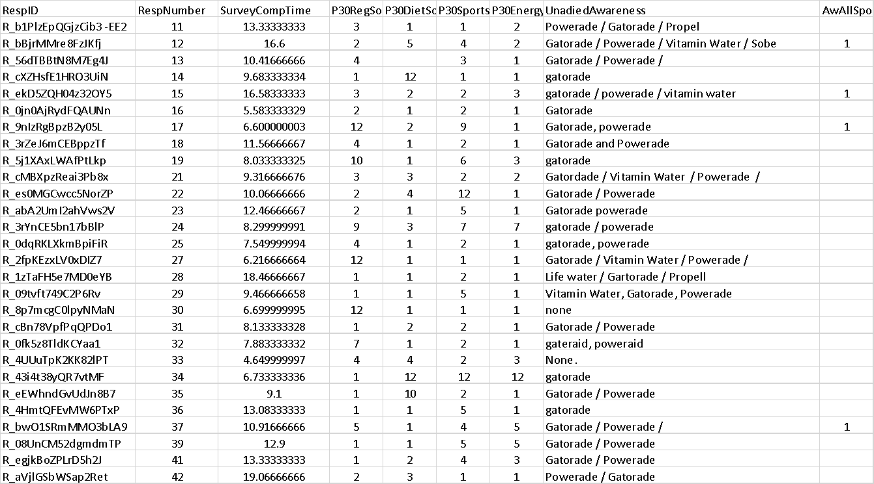

3a. What is the sample size (just type the number below)?

**840**

3b. Assuming that 3000 email invitations were sent out, what is the overall response rate for this research project? Please show your calculation.

**840/3000 = 28%**

4a. In all research projects, analysts go through the process of determining if any respondents should be dropped from the research. As such, there are **TWO quality checks** used in the current research: 1) you will drop respondents who did NOT answer a ‘1’ to the heart attack question for Powerade, and 2) you will drop respondents who did NOT answer a ‘1’ to the heart attack question for Gatorade.

First, create a new variable in XL that identifies each of these two quality check issues. Copy and paste part of your XL spreadsheet that shows these new variables

**Powerade**

**= IF(AQ2 <>1,1,0)**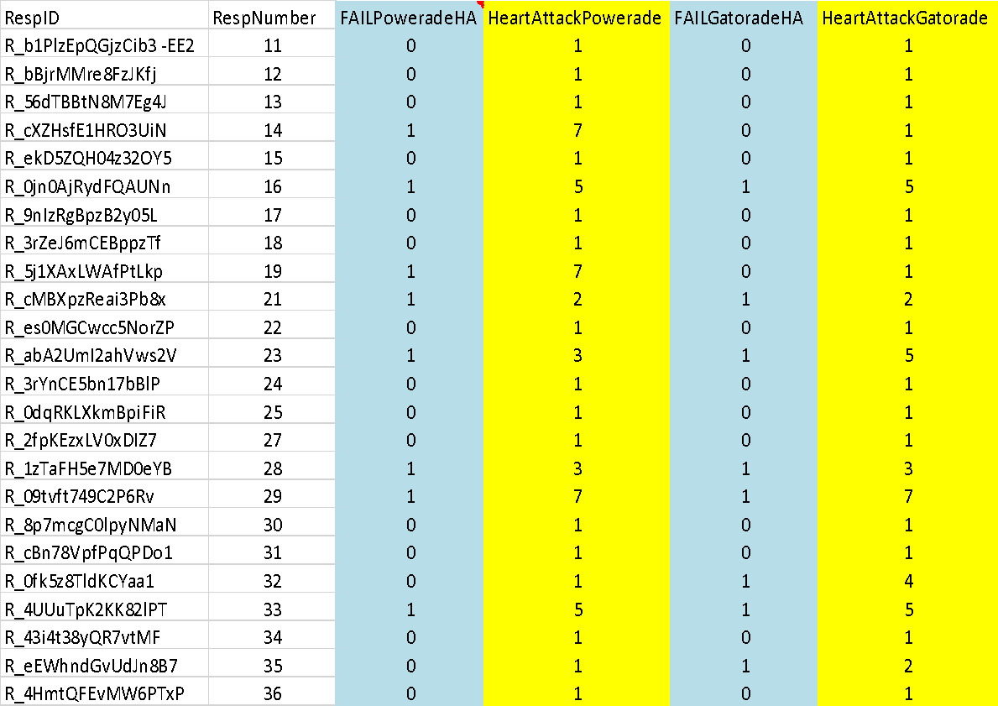

**Gatorade**

**= IF(BG2 <>1,1,0)**

4b. Please create a single pivot table that shows the **number of respondents who are dropped at each of the two quality check questions** listed above. **Copy and paste the pivot table below.**

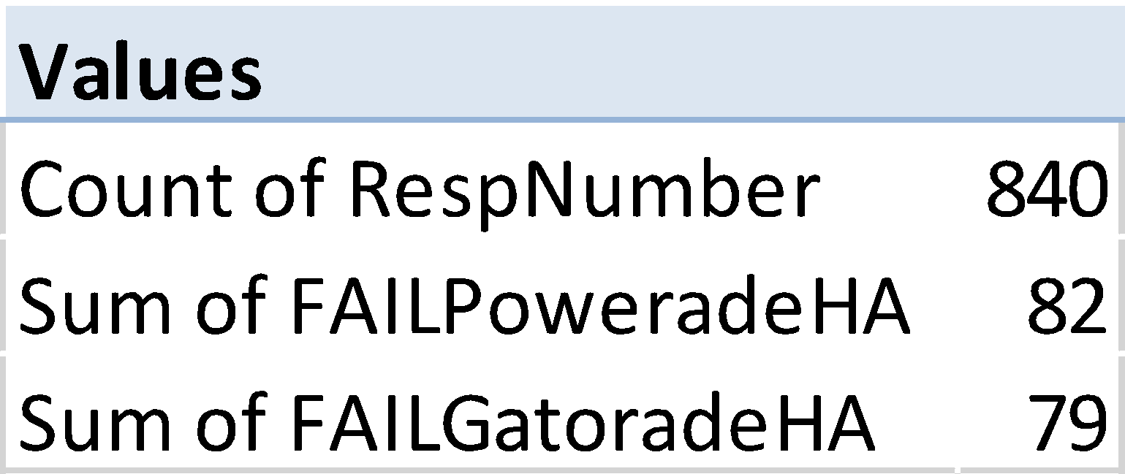

4c. Finally, determine the number of respondents that are dropped in total Note: this will likely be less than simply adding up the numbers for the two quality checks since the some respondent may have “failed” more than one quality check. **Copy and paste the pivot table below.**

**840 – 743 = 97 Failed**

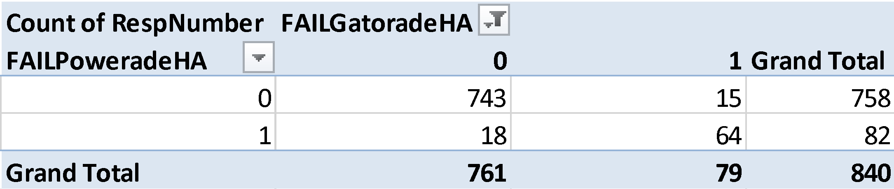

4c**.** Type below the number of respondents that passed all of the quality check questions

**743**

**For the remainder of the assignment (as well as ALL upcoming assignments), use the data file AFTER you have removed respondents who fail one or more of the quality checks.**

5a. Code the awareness question so that it can be analyzed. The raw data for awareness is 1’s and blanks. Please code the responses so that all of the results are “0” and “1” – which is much easier to analyze. **Copy and paste your XL command below.**

**=IF(M2=1,1,0)**

5b. What is the average awareness level for Powerade and its main competitors (in rank order) – copy and paste your pivot table below.

**All of your pivot tables should include the sample size!**

**Remember, the sample size should be AFTER REMOVING RESPONDENTS WHO FAILED ANY OF THE QUALITY CHECK QUESTIONS.**

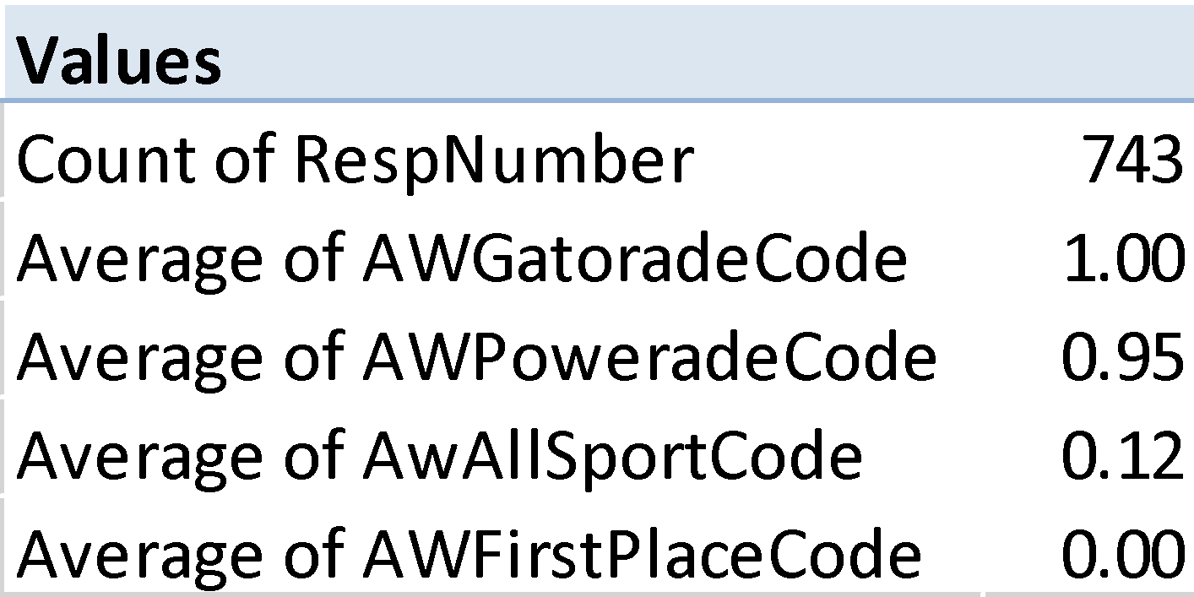

5c. Create a graph in XL that summarizes the awareness for the different drinks in rank order, and copy and paste below.

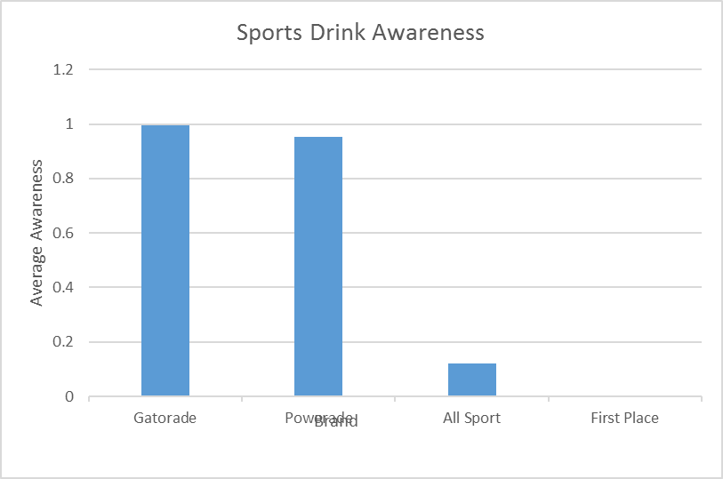

6a. Code the question for the average number of cans used in the past 30 days for Powerade (P30Powerade), Gatorade (P30Gatorade), All Sport (P30AllSport), and First Places (P30FirstPlace) so that it makes logical sense (i.e. a ‘1’ does NOT mean that 1 can was used). **Copy and paste your XL command below.** (Hint, you already thought about this XL code in a prior question)

**=IF(Q2=1,0,IF(Q2=2,1,IF(Q2=3,4,IF(Q2=4,8,IF(Q2=5,11,IF(Q2=6,14,IF(Q2=7,17,IF(Q2=8,20,IF(Q2=9,23,IF(Q2=10,27.5,IF(Q2=11,32.5,IF(Q2=12,35,""))))))))))))**

6b. Create a pivot table that shows the average number of cans consumed (in the past 30 days) for Powerade and its competitors, in rank order. **Include the XL pivot table in your homework.**

**Remember, the sample size should be AFTER REMOVING RESPONDENTS WHO FAILED ANY OF THE QUALITY CHECK QUESTIONS.**

**All of your pivot tables should include the sample size!**

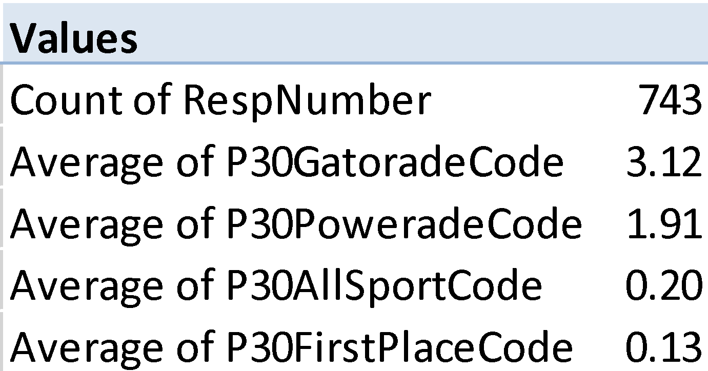

6c. Create a graph in XL that shows the usage patterns for the different drinks in rank order, and copy and paste below.

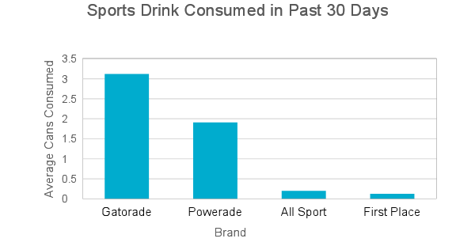

7a. Now code the usage question for Powerade (and its competitors) in a different way. In this case code the data as a ‘1’ if the respondent is a trier of the brand, and ‘0’ if it is not a trier. **Copy and paste part your XL command below.** (Hint: think about what you did to create variables for Powerade triers and Gatorade triers on the prior assignment)

**=IF(Q2="","",IF(Q2>=1,1,0))**

7b. Create a pivot table that shows the percent of triers or buyers (in the past 30 days) for Powerade and its competitors, in rank order. **Include the XL pivot table in your homework.**

**Remember, the sample size should be AFTER REMOVING RESPONDENTS WHO FAILED ANY OF THE QUALITY CHECK QUESTIONS.**

**All of your pivot tables should include the sample size!**

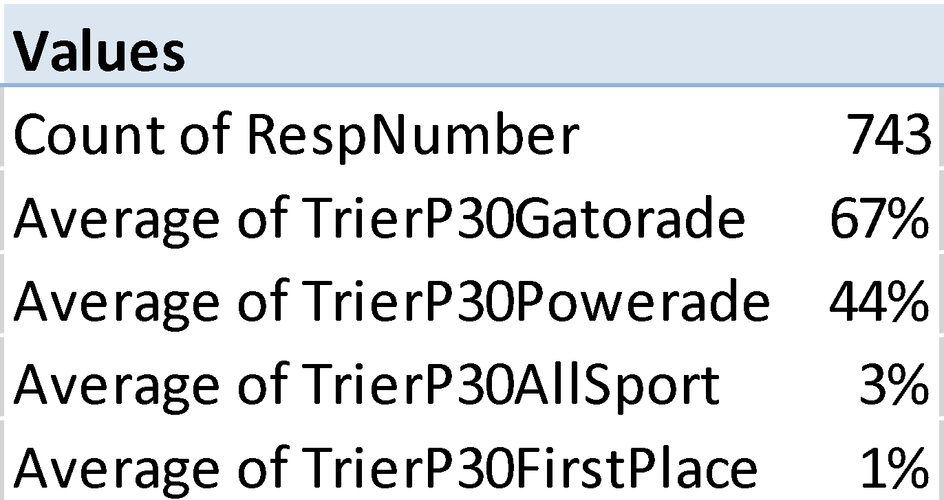

7c. Create a graph in XL that shows the percent triers for Powerade and its competitors, in rank order, and copy and paste below.

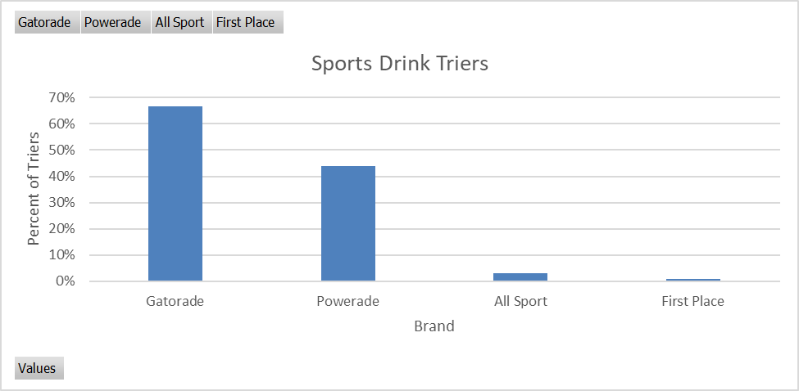

7d. Now code the usage question for Powerade (and its competitors) in a different way. In this case code the data as a ‘1’ if the respondent is a repeater of the brand, and ‘0’ if it is not a repeater. **Copy and paste part your XL command below.** (Hint: think about what you did in the prior assignment)

**=IF(U2="","",IF(U2=0,"",IF(U2>=2,1,0)))**

7e. Create a pivot table that shows the percent repeaters (in the past 30 days) for Powerade and its competitors, in rank order. **Include the XL pivot table in your homework.**

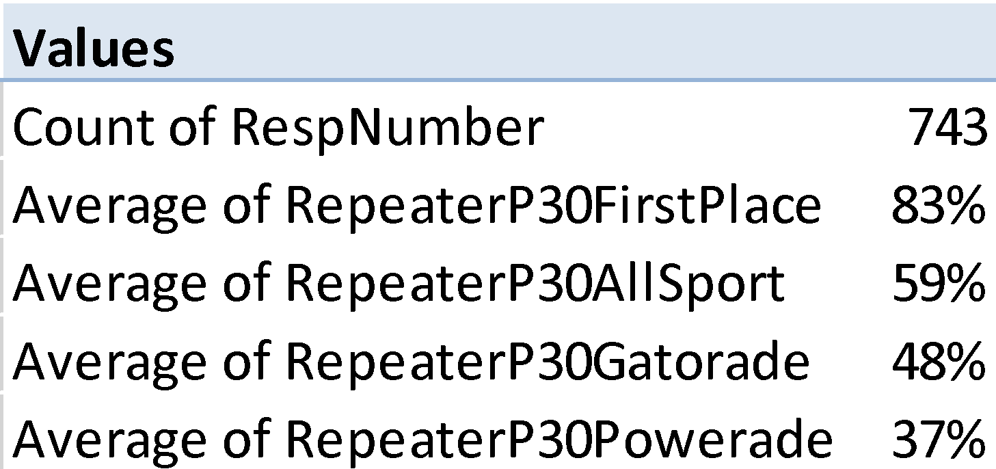

**Remember, the sample size should be AFTER REMOVING RESPONDENTS WHO FAILED ANY OF THE QUALITY CHECK QUESTIONS.**

**All of your pivot tables should include the sample size!**

7f. Create a graph in XL that shows the percent repeaters for Powerade and its competitors, in rank order, and copy and paste below.

